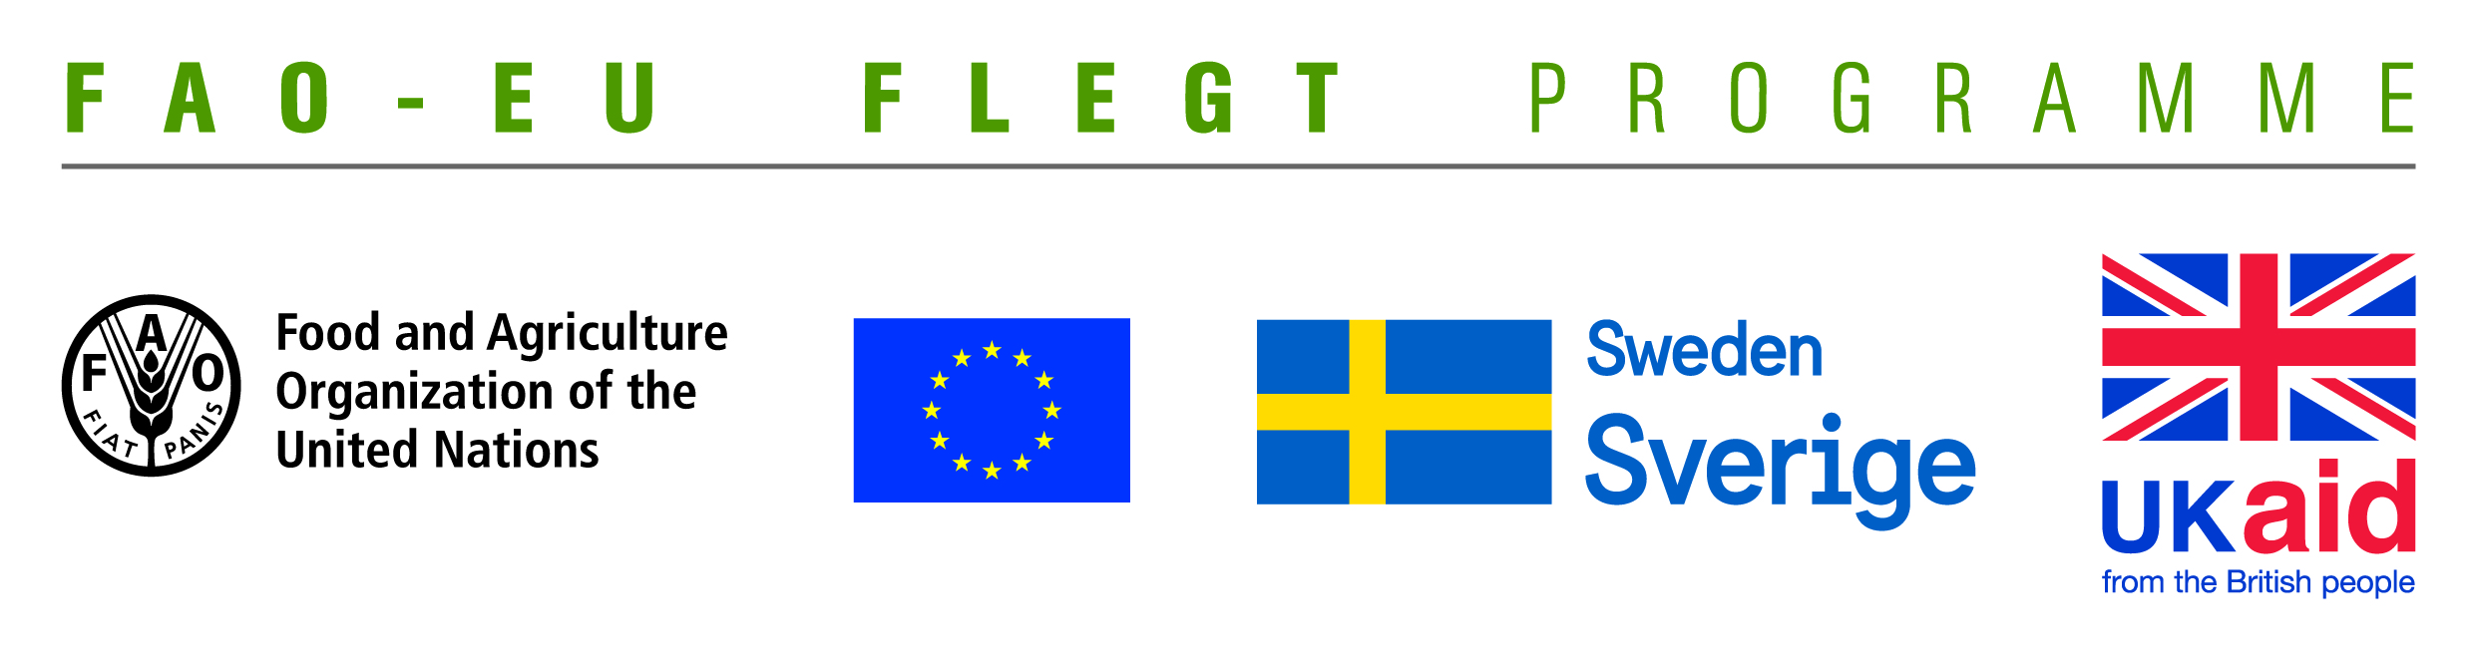
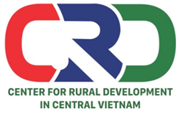

TERMS OF REFERENCE (TOR)

Project name | Supporting small business holders comply with LD requirements in order to effectively participate in national and global legal timber supply chains
Job Title | Looking for a consultant to facilitate and moderate ToT courses for local CSOs on how to introduce VPA/FLEGT and LD to household forest growers, identify their compliance gaps and support them to close the gaps
Contracting Organization | Centre for Rural Development in Central Vietnam (CRD)
Location | Hue and Quang Tri provinces
Time | From February to March 2020

- Background information
The EU-FAO FLEGT Programme provides financial assistance for the implementation of Voluntary Partnership Agreement on Forest Law Enforcement, Governance and Trade (VPA/FLEGT) in the countries. This programme aims to improve forest management and protection, capacity building and technical support through projects in forestry area. The EU-FAO FLEGT Programme supports Vietnam on developing Vietnam’s Timber Legality Assurance System (VNTLAS), reinforcing the commitment of the wood processing industry in the region to create a legal source of wood, harvesting timber in a sustainable way and focusing on the capacity building activities for relevant agencies and stakeholders to implement effectively VPA/FLEGT Agreement.
Centre for Rural Development in Central Vietnam (CRD) is implementing the project “Supporting small business holders comply with the LD requirements in order to effectively participate in national and global legal timber supply chains” funded by EU-FAO FLEGT Programme via the Food and Agriculture Organization of the United Nations (FAO). The project, in collaboration with the Center for Education and Development (CED) and Center for People and Environment of the Central Highlands (COPE), is implemented in Quang Tri and Dong Nai provinces. The project aims to support small business holders to comply with the LD and VNTLAS requirements to effectively participate in national and global legal timber supply chains.
To update information on the implementation of the VPA/FLEGT Agreement and legal timber requirements for forestry authorities, civil society organizations and large timber plantation households, especially the household forest growers with the FSC certificate. The project will organize the Training of Trainers (ToT) course in 03 days on the following contents: Introduction of the VPA/FLEGT Agreement; Legality Definition (LD); how to Identify compliance gaps of household forest growers and provide support to meet legal timber requirements. Fifteen (15) participants from the state management agencies on forestry; civil society organizations in the project area; and representatives of FSC-certified groups of households will participate in the training course. After the ToT course, participants will organize five (5) re-training courses (2 days per course) for households with the FSC-certified or large timber forests in the locality. Therefore, the CRD is looking for a consultant with professional knowledge and good experiences to facilitate and moderate for the ToT course in Hue and Quang Tri provinces.
- Training objectives
- Enhancing knowledge for trainers on the VPA/FLEGT Agreement and Legality Definition.
- Providing training methods and skills to trainers to re-train household forest growers with the FSC-certified and large timber in the locality.
- Tasks and duties
- Prepare the training agenda for two training courses of ToT in 3 days and a re-training course in 2 days.
+ Materials of the ToT course in 3 days including contents: VPA/FLEGT Agreement and requirements; Definition of legal timber related household forest growers; Vietnam's timber legality assurance system (VNTLAS); method to identify compliance gaps and to provide technical support for closing gaps; basic skills to conduct re-training
- Materials of the re-training course in 2 days: Simplifying the ToT materials which do not include basic skills to conduct re-training
- Facilitate and moderate ToT courses including 2 days for theory and 1 day for practice training skills
- Monitor and provide technical supportduring re-trainings conducted by those have participated ToT above.
- Prepare the training evaluation forms for trainees, including 2 forms: pre and post training evaluation forms.
- Write report on the ToT course and report on re-training.
- Deliverables
- Two ToT training agenda in 3 days and a re-training agenda in 2 days.
- Pre and post ToT training evaluation forms.
- Training materials, including: (i) ToT training materials in 3 days; (ii) re-training in 2 days
- Pre and post training evaluation forms.
- 02 post-training report for ToT and re-trainings
- Requirements of the Consultant’s Qualifications and Experiences
- At least university degree in forestry or forestry related fields
- Good knowledge on forestry laws and VPA/FLEGT, LD, VNTLAS related issues.
- At least 5 years of working experiences in facilitating trainings
- Experiences in working with NGOs, CSOs and timber processing enterprises is preferred.
- Good skills to promote and operate group discussions.
- Implementation period
- ToT courses will be conducted during March 10-15, 2020.
- The (02) types of training materials must be sent to the project at least 5 days prior to the start of the ToT course.
- Training reports will be finalized and sent to the project at least 01 week after ending the training courses.
- Management and Organization
- Center for Rural Development in Central Vietnam is the host of the training course.
- A Local Network for VPA/FLEGT Implementation in Quang Tri province cordinate training courses.
- Consultant implements this activity under the project staff ‘s support and supervision
- CRD will discuss specifically with the selected consultant about the training contents (of both ToT and re-training courses) before he/she prepares the training materials.
- The consultant is responsible for the purchase of occupational, medical, accident, travel and other similar insurances during the contract implementation.

Interested candidates are invited to send CVs via email no later than 4 March, 2020: namnv@crdvietnam.org with cc huongnl@crdvietnam.org

